To order, please fill in the form below and post to Luing Cattle Society Secretary, Una MacQueen, Mount Blair, 10 Manor Gardens, Blairgowrie, Perthshire, PH10 6JS - Please DO NOT send any payment with your order form!
L
u
i
n
g

C
a
t
t
l
e

S
o
c
i
e
t
y

-

M
e
r
c
h
a
n
d
i
s
e

O
r
d
e
r

F
o
r
m
Don’t forget you can have your herd name added too above the logo for an extra charge of £3 per garment.
Item | Size | Colour | Qty | Price
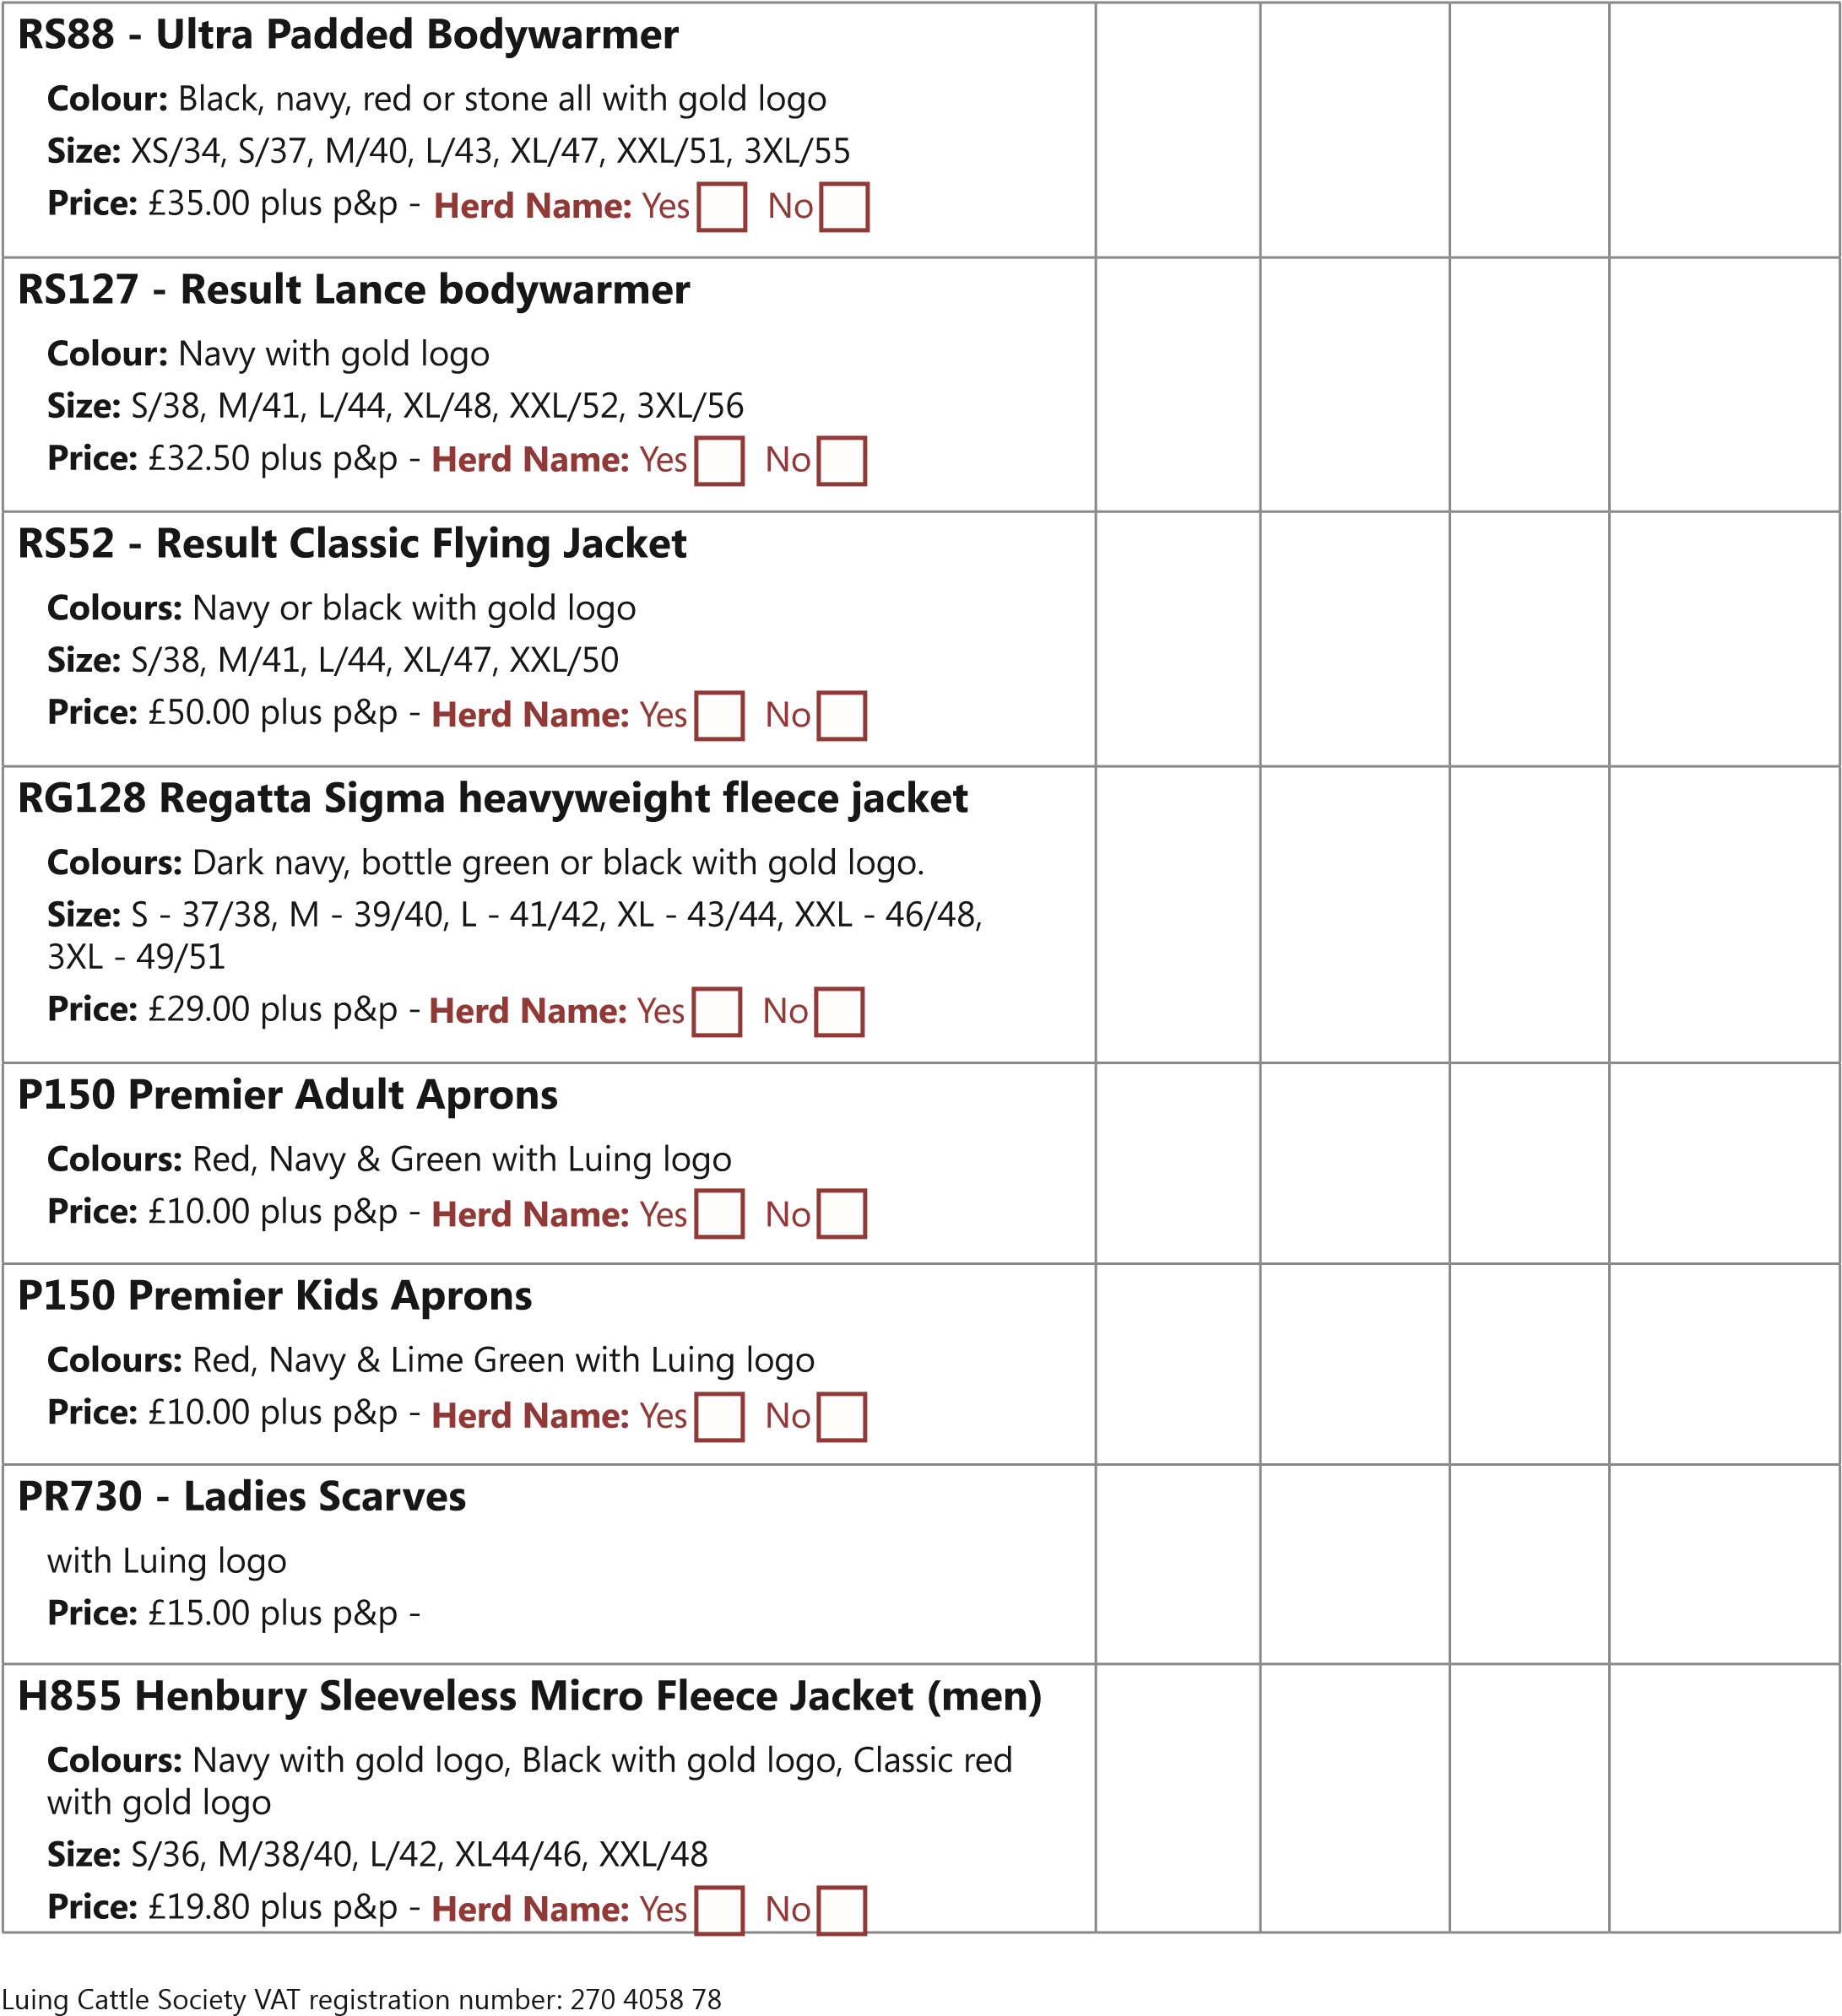
H856 Henbury Sleeveless Micro Fleece Jacket (ladies)
Colours: Navy with gold logo, Black with gold logo, Royal blue with gold logo
Size: S/10/34, M/12/35.5, L/14/37, XL/16/39, XXL18/41
Price: £17.69 plus p&p - Herd Name: Yes/No
PW134 Coveralls
Colours: Navy or Black
Leg: Reg 31 or Long 33
Size: S (36/38), M (40/41), L (42/44), LX (46/48), XXL (50/52)
Price: £30 plus p&p - Herd Name: Yes/No

JH001 Hoodies (Mens)
Colour: Denim or bottle green
Size: XS – 5XL (34-64)
Price: £20 plus p&p - Herd Name: Yes/No
Herd Name on back: Yes/No (£5.00)
JH001F Hoodies (Ladies)
Colour: Red hot chilli or lime green
Size: XS-SSL (8-18)
Price: £20 plus p&p - Herd Name: Yes/No
Herd Name on back: Yes/No (£5.00)
JH002B Supasoft Baby Hoodie
Colour: Supa Hot Pink, Supa Royal
Size: 6-9 months, 9-12 months
Price: £15 plus p&p - Herd Name: Yes/No
JH001B Kids Hoodies
Colour: Hot Pink, Royal Blue
Size: XXS (1-2yrs), XS (3-4), S (5-6), M (7-8), L (9-11), XL (12-13)
Price: £15 plus p&p - Herd Name: Yes/No
RS33B Kids/Youths Polartherm Fleece
Colours: Red & Navy
Size: 3-4yrs, 4-6, 6-8, 8-10, 10-12
Price: £18 plus p&p - Herd Name: Yes/No
Size: 12-14yrs,
Price: £20 plus p&p - Herd Name: Yes/No
BB57 Beechfield heavy brushed low-profile cap  Colours: French navy / taupe with white logo. Forest / taupe with gold logo  Price: £8.50 plus p&p - | N/A
Luing tie design 1  Colours: Wine or Navy  Design: Gold Logo with small gold Luing heads as pattern Price: £20.00 plus p&p | N/A
Luing tie design 2  Colours: Wine or Navy  Design: Gold Logo with dark logos as pattern  Price: £20.00 plus p&p | N/A
BB45107055 Beechfield cuffed beanie ADULT  B45B107075 Beechfield cuffed beanie CHILD  Colour: French navy with logo  Price: Adult £8.50 plus p&p  Child £7.50 plus p&p | N/A  N/A

Name: TOTAL:
Item | Size | Colour | Qty | Price
Address:
www.luingcattlesociety.co.uk
Luing Cattle Society VAT registration number: 270 4058 78

Post Code: E-mail:
Telephone: Mobile:
Herd Name:
(Herd name only to be completed if required. £3.00 per garment.)

